James Moran

This document is the Post-Mortem Report of the game put together for CGP605: Mobile Applications.

James Moran, Q12494305, CGP605, AE2

Post-Mortem

Contents

**No table of contents entries found.**

# Project Tracking

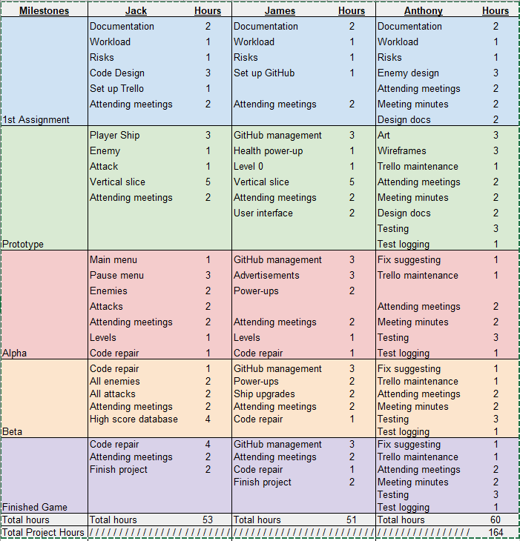For our project, we put together a group-workload sheet, with the delegated tasks for each member of the group and the hours that they were expected to take on each of these tasks. This is shown below:

From this, we were able to put together a PERT-chart, for an overview of the tasks due for completion, at each stage of the project. A copy of this, can be seen on the next page:



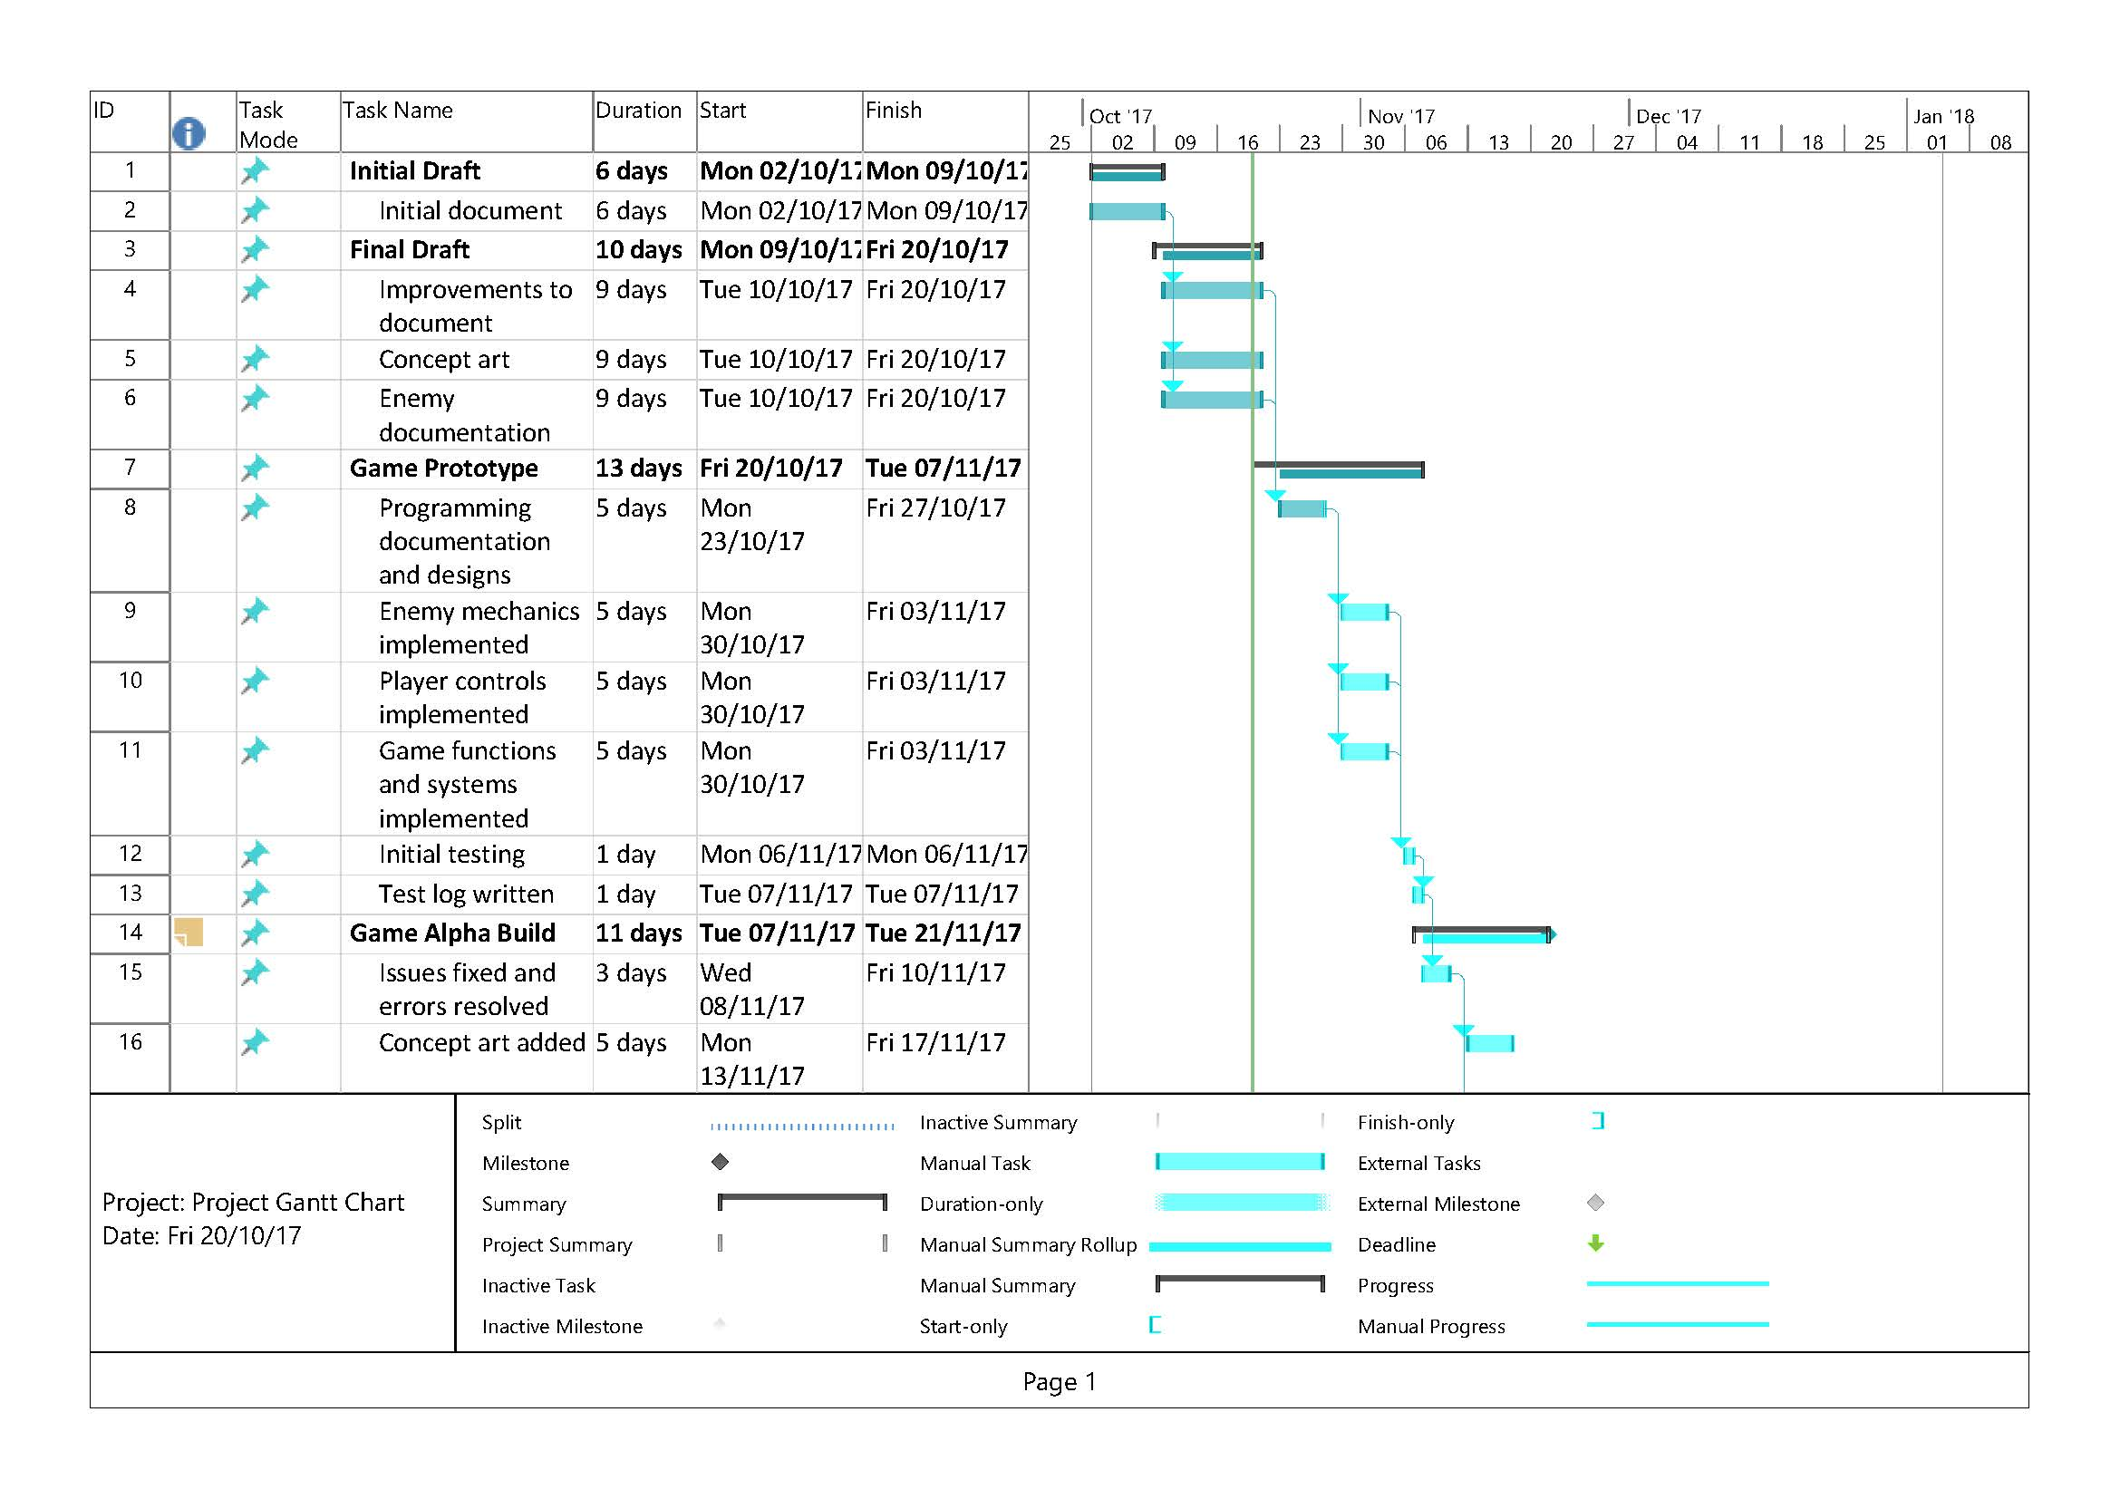Along with the above chart, we also put together a Gantt-Chart, for greater detail on each task due for completion. The screenshot of the first page of this chart is shown below:

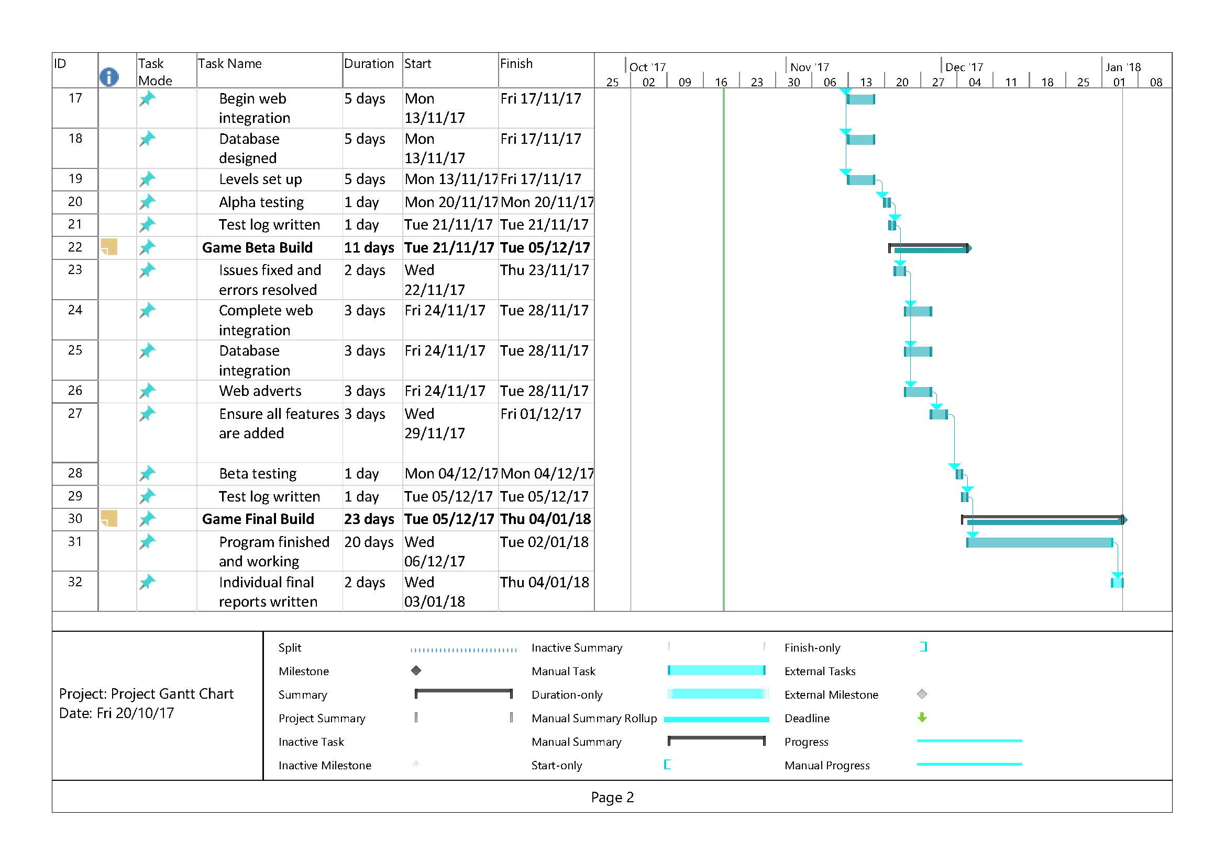Then the second page:

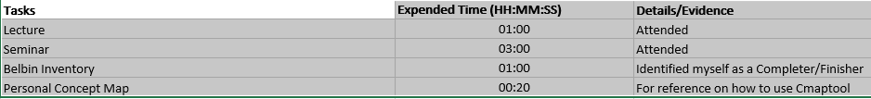I kept my progress on track for the project, by logging my progress in a table, that is editable online. This table is similar in layout to the table that I put together for group-work in Engineering Software Systems, last year. A sample of this table, is shown below:

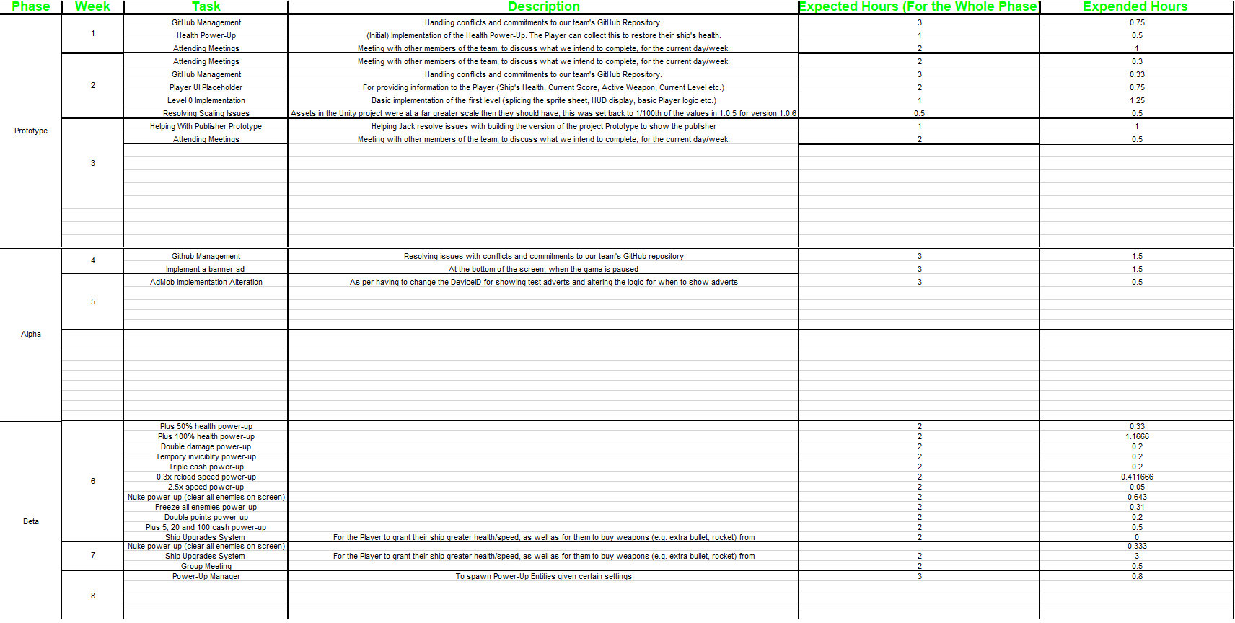So, for each phase of the project (putting together the Project Proposal, Prototype, Alpha, Beta and the Finished Game), each group member is expected to complete certain tasks as per the phase of the project (e.g. for the Project Proposal Phase, I was expected to consider the Risks of the project, provide documentation on the tasks I had further down the line and how I would manage the Workload). I was given the project-long responsibility of setting-up a GitHub repository and managing it (resolve conflicts between branches, properly merging branches etc.). A copy of my week-by-week time-log, can be seen below:

Each team member was also allowed to review the meetings of a particular week, as Anthony took the minutes of each meeting, that we could use for continuous reflection throughout the project. A sample of these minutes, is shown below:

____________________________________________________________________________

This group meeting took place on the 4th of December 2017, at 4:50 PM.

People present: Anthony Boys, Jack Evans, James Moran.

People absent: none.

In this meeting, we discussed an update in the plan for this project.

Firstly, we discussed what we hope to complete by the new beta deadline, which is between the 8th and 26th of January. However, we still agree to have the software product completed by the holidays, as the reports can be worked on over the holidays, and with the remaining days that are both before the report deadline, but after the holidays.

Secondly, we reminded ourselves of the tasks that need to be completed and assigned tasks that have not been mentioned before. Jack is to create screens for level completions and game overs, a system for transitioning between levels, and is planning on setting up the database; James is to pool power-ups, create a power-up spawning system, and will modify the upgrade store; and Anthony is to test the product next week.

Finally, the group realised that they need to be adhering to the same coding standard; also, they will also observe the test log, as they need to see if any features are missing on it. (Antony Boys, 2017)

We used Trello, for a team-level overview of which tasks team-members were currently completing, as well as for communicating certain matters on the project, putting up notes going into further detail for certain aspects of the project etc. A sample of the Trello-Boards we put together, can be seen on the next page.

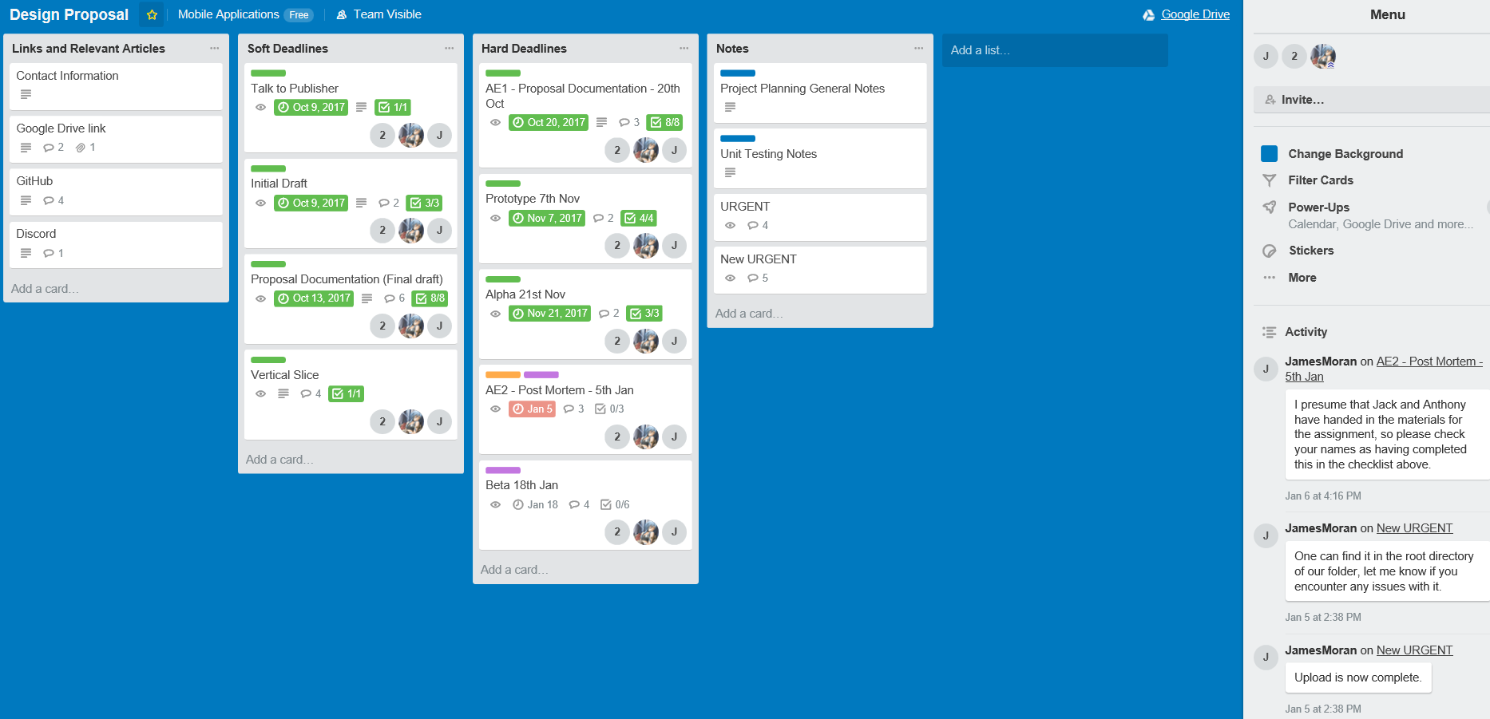Design Proposal Trello Board:

User Stories Trello Board:

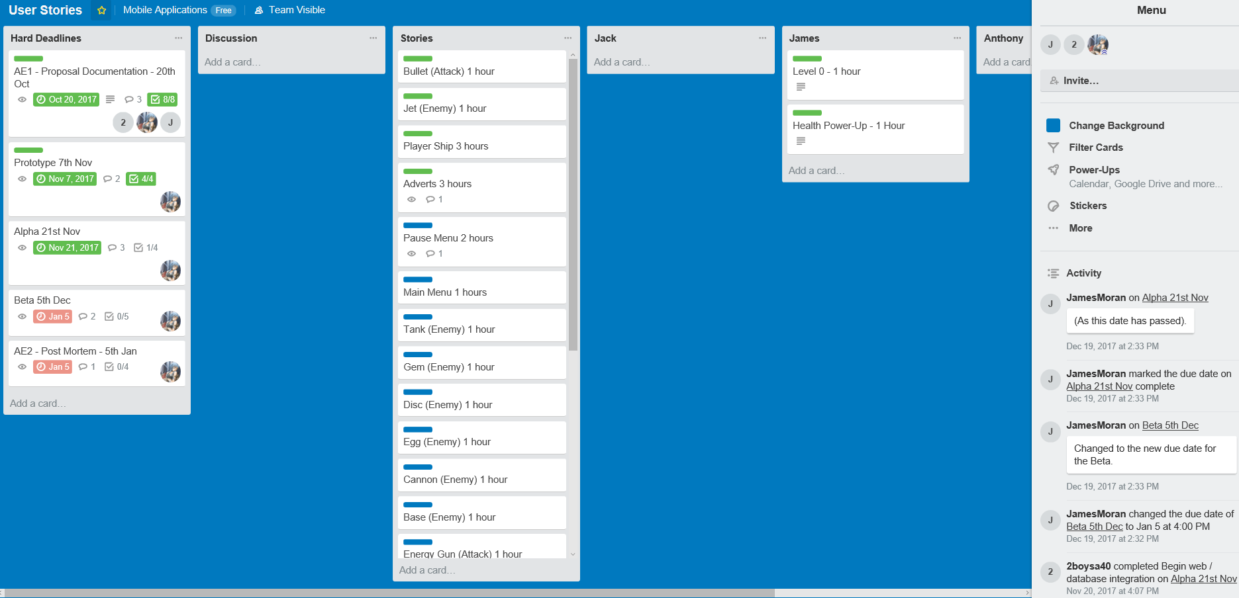

I also communicated with Jack via Discord (a free, Instant-Messaging (IM) and Voice Over Internet Protocol (VOIP) application). A sample of the IM between me and him, is shown below (I am known by the alias FioKron and Jack by the alias TheAkashicTraveller):

## **TheAkashicTraveller**-**10/20/2017**

What time are we calling cut off for this? So that we all hand in the sam ething.

## **FioKron**-**10/20/2017**

I would say by 15:00 at the latest

(Working on my AGP assignment atm)

Would you say that this is suitable time, for a fair cut-off point?

## **TheAkashicTraveller**-**10/20/2017**

Yeah

## **FioKron**-**10/20/2017**

Alright

## **TheAkashicTraveller**-**10/20/2017**

Have you managed to tell Anthony this? I put it in the comments but he hasn't replied.

## **FioKron**-**10/20/2017**

I will try to find him...somehow

There is IM chat functionality via Google Drive, I have posted a message in that group chat for our Drive folder.

## **TheAkashicTraveller**-**10/20/2017**

I just texted him and he said that he's done with everything

If you are to we can just upload now

*too

?

## **FioKron**-**10/20/2017**

I am ready

## **TheAkashicTraveller**-**10/20/2017**

Lets do it then

Done

## **FioKron**-**10/20/2017**

I have submitted my copy as well.

## **TheAkashicTraveller**-**10/20/2017**

## **FioKron**-**10/20/2017**

Great work team, get ready for the next round...

## **TheAkashicTraveller**-**10/20/2017**

Heh yeah

## **FioKron**-**10/20/2017**

## **TheAkashicTraveller**-**10/20/2017**

We should probably get a basic unity project up on the master branch so that we can all start.

## **FioKron**-**10/20/2017**

In due course mind, but I agree, that would make sense.

Finally, text-messages were also used on occasion (only between me and Jack though), as another means of communication, if one was not able to access the Discord application.

# Reflection

## Negative Aspects

* Clashes between me and another team-member: These were on certain components of the project, such as how collision should be handled, issues relating to coding standards and misunderstanding between me and him, on what issues we were currently facing, or success stories for certain User-Stories (mistaking one for the other)
* Concerning Modularity: As was initially planned for the project, we had intended for there to be multiple levels, with enemies having different attack patterns (causing the Player to have to adopt new movement strategies for dodging Enemy projectiles), as well as different types of enemies (commander, boss, spawner), which would have different stat lines. Even so, we had not tried to make the project’s implementation in Unity (the game engine we used), modular, which would allow for an iterative pattern to develop new levels and introduce new enemy-types to the Player (as for the one level we had, many of its assets were static for that level, not considering different types of enemies and attack patterns for example)

## Positive Aspects

* Project Tracking: We made sure to track our progress in the project, by using our own timesheet’s (a sample of mine is shown in Fig. 3 of Appendix A: Figures), as well as meeting at least once a week, to discuss our current progress and to delegate any ‘loose’ tasks (that were not delegated), to a suitable team-member
* Task Completion: Once the tasks were distributed (either in the initial stages or from a team-meeting), we all completed the tasks we had been delegated, to the best of our ability, considering the time we had predicted for each task (although, the tasks were not delegated in the fairest manner, see the Improvements section for further detail into this)

# Improvements

* Development Standards: No standard was adopted by the team, other than the one for the tracking system we used, in development of the project. This includes no Coding-Standard for the C#-scripts we assembled for use in the Project’s Unity implementation, as well as standards for assembling other assets in Unity (such as ‘prefabs’, accounting for modularity to use them at multiple points in the project). Therefore, standards to normalise the development process across the whole team (so we would be ‘on the same page’), for at least what has been mentioned, should have be adopted from the beginning, for future team-projects
* Properly Delegating Tasks: Although we made sure to delegate all the necessary tasks for completion, evenly (in terms of the quantity of tasks), between each team-member, we would not have considered which team-member was best suited to a task. Therefore, when delegating tasks, a team should properly analyse whom would be best suited at completing a task, given the predicated time for that task, as well as a given team-member’s skillset. A system should be adopted for consistent analysis of task-delegation, at any stage of the project
* Utilising a system to account for ‘slack’: Although we had a very capable tracking system in place for the tasks we had delegated ourselves in the first instance, there was no system to allow for a team-member whom had completed the tasks assigned to them, to help other team-members with tasks they were having issues with, or to initiate tasks that had not been delegated to the team. Therefore, it would make sense adopt a system to allow team-members to pick-up ‘slack’, for task-progress, to make sure a team-member was not left idle at a certain stage in the project, when they could be getting on with other tasks that are suitable for them to complete, or helping other team-members with any issues they are having with their tasks

# Appendix A: Figures

Figure 1: All the minutes for our meetings, put together by Anthony Boys:

____________________________________________________________________________

This group meeting took place on the 2nd of October 2017, at 5:00 PM.  
People present: Anthony Boys, Jack Evans, James Moran.

People absent: none.

In this meeting, we first of all set up a GitHub and Trello board for the project.  
Finally, we discussed an idea for the project. We all agreed that the design will be a simple game, with the genre of either “bullet hell” or “space invaders”; that the game may have controls that are alternative to using an accelerometer or gyroscope; that there may be a system of player progression; that there will be differing enemies, including boss enemies; that difficulty will increase over levels; and that there may be power-ups, health pickups, drops and end-of-level bonuses.

____________________________________________________________________________

This group meeting took place on the 6th of October 2017, at 9:35 AM.

People present: Anthony Boys, Jack Evans, James Moran.

People absent: none.

In this meeting, we discussed what tasks we want to complete by Monday, in order to begin the project, and get it off to a good start.

Firstly, we agreed to complete the first draft by Monday.

Secondly, we allocated tasks. Anthony is to create concept art and characteristics of both the player and enemy ships, and additionally look at and begin work on the risk analysis; Jack is to look into options for controls and also look into possible software development lifecycles; James is to look at GitHub in relation to its uses for the source code and the project files, and additionally to begin a Gantt chart for general work.

Finally, we agreed that we need to meet our client on Monday, as that will provide us with the opportunity to discuss the solution that we propose, and become aware of any changes that may need to be made in order to meet requirements.

____________________________________________________________________________

This group meeting took place on the 9th of October 2017, at 4:25 PM.

People present: Anthony Boys, Jack Evans, James Moran.

People absent: none.

In this meeting, we discussed the progress we have made since the last meeting, in relation to completing the first of the soft deadlines.

Firstly, we noted that Anthony has worked on the character attributes; Jack has looked at control models, the “incremental” development model, requirement modules, the work breakdown structure, and activity sequencing; and James has looked at the tracking system.

Secondly, we assigned tasks to be worked on during the middle of the week, and that we ought to have completed by Friday. Anthony is to continue working on the enemies, and is to begin the concept art, the risk analysis, the asset list, and a Pert chart. Jack is to work on the schedule, workload and user stories section of the design document; and James is to work on the remained of the design document.

Finally, we noted that we need to apply our names to the sections of the design document that we have completed.

____________________________________________________________________________

This client meeting took place on the 9th of October 2017, at 5:00 PM.

People present: Anthony Boys, Jack Evans, James Moran; Nick Thomas.

People absent: none.

In this meeting, we informed our client on our initial proposal for our idea for the game; the fact that we may be using an alternative control scheme, and relevant screen layouts; that we are undecided in terms of revenue model; that we will use a database to store high scores upon a player’s death, and that we will be using the “incremental”

After that, we received feedback on our idea. We were advised that unusual control schemes will require particular user interface designs to ensure the game is playable, in a discussion about the layout type; that an advertisement system would be the best form of revenue model for the game as it currently stands; that our idea for a database system is sufficient; and that our choice of development model is acceptable.

____________________________________________________________________________

This group meeting took place on the 13th of October 2017, at 9.25 AM.

People present: Anthony Boys, Jack Evans.  
People absent: James Moran.

In this meeting, we briefly looked over the assignment, and discussed progress.

Firstly, we made all of the online documents accessible to the team.  
Secondly, we discussed progress. Anthony has completed all tasks, except the Pert, which is almost complete; and that Jack has completed the majority of his tasks, except for the tasks that we realised needed group discussion; as group discussion could not take place with the absence of James.  
Thirdly, we discussed which tasks need a discussion. The risk and workload sections require a full group discussion, and additionally the Gantt chart.

Finally, we discussed that we also need to complete our own individual iterations of the workload and risk sections.

____________________________________________________________________________

This group meeting took place on the 16th of October 2017, at 4:30 PM.

People present: Anthony Boys, Jack Evans, James Moran.

People absent: none.

In this meeting, we discussed the tasks that we need to complete, in order to successfully complete the first assignment.

Firstly, we agreed that we need to complete the workload and risk sections, as both individuals and a group.

Secondly, we discussed the individual tasks that we are to do. Anthony is to work on the wireframes, create new ideas for power-ups, and additionally revise both the Pert and Gantt charts; Jack is to look at user stories, activities and the program design; and James is to finish the assignment, as well as being placed in charge of the GitHub.

Thirdly, we discussed iteration and evolution methods, and decided that we will use the methods that we have previously decided upon.

____________________________________________________________________________

This client meeting took place on the 16th of October 2017, at 5:05 PM.

People present: Anthony Boys, Jack Evans, James Moran; Nick Thomas.

People absent: none.

In this meeting, we shown our client the design document.

After that, we received feedback on this design document. We were advised that the “design” section should explain what the game is, and how it will be coded; that the tracking systems required a greater, more detailed explanation; that the user stories need improvement; that the alpha stage consists of a bare and vague game; that the beta stage consists of a game that contains all the features, but may just have a few errors or issues; and that the workload needs to be fairly split.

____________________________________________________________________________

This group meeting took place on the 23rd of October 2017, at 5:05 PM.

People present: Anthony Boys, Jack Evans, James Moran.

People absent: none.

In this meeting, we discussed the tasks that we would work on over the next week.

Firstly, we all agreed that we, as a group, need to have some form of time sheet, in order to track our progress and project contributions, as well as the hours that we have put in, compared to the predicted hours displayed in the workload sheet.

Secondly, we chose individual tasks for ourselves. Anthony is to work on the wireframe designs; James is to look at the AdMob system, and to also look at a branch of GitHub for testing purposes; and Jack is to research leaderboard systems, and to create a prototype of controls for the player ship, as well as begin work on the mechanics for basic enemies.

____________________________________________________________________________

This group meeting took place on the 30th of October 2017, at 4:45 PM.

People present: Anthony Boys, Jack Evans, James Moran.

People absent: none.

In this meeting, we discussed the progress that we had made over the past week, as well as the tasks that we will be completing over the next week.

Firstly, we noted that Anthony has completed the wireframes in landscape form; Jack has worked on the player controls; and James looked at ways of generating levels systematically. Secondly, we stated that we have, and will, keep updating the individual time sheets.

Thirdly, we discussed the tasks that we will complete over the week. Anthony will create portrait editions of the wireframes; James is to look at user interface; and Jack is further work on the program.  
Finally, we all agreed that we will look at level setup possibilities on Friday, as we will have more of the game’s assets completed by then.

____________________________________________________________________________

This group meeting took place on the 3rd of November 2017, at 9.25 AM.

People present: Anthony Boys, Jack Evans, James Moran.

People absent: none.

In this meeting, we discussed the progress that we have made over the week.

James has implemented functionality in the power-ups, most notably the health power-up; Jack has continued working on the controls, and has now included a mechanic for shooting; and Anthony has completed all the wireframes.

____________________________________________________________________________

This client meeting took place on the 6th of November 2017, at 5:40 AM.

People present: Anthony Boys, Jack Evans, James Moran; Nick Thomas.

People absent: none.

In this meeting, we informed the client that all of the features that we currently have, works.

Firstly, we shown the prototype, as the prototype needs to be completed the next day. It displayed player movement and shooting, and had placeholder assets resembling an on-screen display and interface.

After that, we received feedback. We were advised that the speed of movement needs regulating; the fact that you need to have 2 fingers on the screen to shoot, one to move, the other to shoot, is an issue that needs to be looked at; and that that we do not need to have so many art assets, as we could have one of each article and texture them accordingly.

Additionally, we discussed that we are to have banner advertisements in menus, interstitial advertisements in between levels, and that the high scores database is in the planning.

____________________________________________________________________________

This group meeting took place on the 20th of November 2017, at 4:10 PM.

People present: Anthony Boys, Jack Evans, James Moran.

People absent: none.

In this meeting, we discussed the progress that we have made over the previous 2 weeks.  
Jack has added a health bar, a pause menu, and a level zero that contains stationary green tank enemies that just shoot forward; James has implemented advertisements into the pause menu and the game; and Anthony has written a complete and comprehensive test log that summarises all of the functions within the game and their expected outcomes, and also has created a copy of the sprites, except they are all white articles that can be textured accordingly.

____________________________________________________________________________

This client meeting took place on the 20th of November 2017, at 4:15 PM.

People present: Anthony Boys, Jack Evans, James Moran; Nick Thomas.

People absent: none.

In this meeting, we began by showing the client the game in its current form, due to the fact that the Alpha phase is due the next day.

Firstly, we shown the game, which had a pause menu, stationary shooting enemies, and a health bar.

After that, we received feedback on the game. We were informed that our menu works adequately; that we are mostly up to date with the product needing to be at alpha stage; that we currently only have a “level zero”, and we need to implement actual levels, that contain more enemies; that we were informed that the code for advertisements to appear exists but not functioning at present; that the issue of the group appearing to be working on separate branches of the program needs to be addressed; that the program needs to be tested, but only after more levels have been added; and that the client is overall pleased with how the game is progressing, but more needs to be done in relation to milestone-specific tasks by the next deadline, as there is a slight concern that we may be falling behind slightly.

Finally, we shown our client our group workload sheet, and our individual timesheets, to reinforce the notion that we are up to date with our project, and the process of implementation.

____________________________________________________________________________

This group meeting took place on the 24th of November 2017, at 9:30 AM.

People present: Anthony Boys, James Moran.

People absent: Jack Evans.

In this meeting, we discussed what we are going to have completed by Monday.

Firstly, we noted that we haven’t furthered any work on the project since the tasks we completed on Monday, due to other commitments.

Secondly, James is now aware on the specifics of the power-ups and the player ship upgrades that are to be added during this phase of development, and Anthony is to look at image file types in order to find the best file type to store the sprite sheets as

Finally, in his absence, Jack is to be delegated the task of database management, but this will require discussion at the meeting in which he is next present.

____________________________________________________________________________

This group meeting took place on the 1st of December 2017, at 9:35 AM.

People present: Anthony Boys, Jack Evans, James Moran.

People absent: none.

In this meeting, we discussed what we have worked on over the past week, and what we hope to have completed by Monday.

Firstly, we discussed what we have recently done. Jack has created a scrolling level, that has a matching adjustable background. No other team members have worked on the project, due to other commitments.

Secondly, we discussed what we hope to get done by Monday. Jack is to pool enemies to spawn after some are destroyed, and will also pool bullets after they travel a certain distance due to the level being of a longer area; James is to work on the ship upgrade system through using test templates and test values; and Anthony is to test the entire program once it is developed to a testable standard.  
Finally, as a group, we agreed to finish at least the software product before the holidays, with mention of additionally completing all of the reports by the holidays too, in order to be able to submit the finished product at a convenient time.

____________________________________________________________________________

This group meeting took place on the 4th of December 2017, at 4:50 PM.

People present: Anthony Boys, Jack Evans, James Moran.

People absent: none.

In this meeting, we discussed an update in the plan for this project.

Firstly, we discussed what we hope to complete by the new beta deadline, which is between the 8th and 26th of January. However, we still agree to have the software product completed by the holidays, as the reports can be worked on over the holidays, and with the remaining days that are both before the report deadline, but after the holidays.

Secondly, we reminded ourselves of the tasks that need to be completed, and assigned tasks that have not been mentioned before. Jack is to create screens for level completions and game overs, a system for transitioning between levels, and is planning on setting up the database; James is to pool power-ups, create a power-up spawning system, and will modify the upgrade store; and Anthony is to test the product next week.

Finally, the group realised that they need to be adhering to the same coding standard; also they will also observe the test log, as they need to see if any features are missing on it.

____________________________________________________________________________

This group meeting took place on the 11th of December 2017, at 4:20 PM.

People present: Anthony Boys, Jack Evans, James Moran.

People absent: none.

In this meeting, we discussed the progress that we have made recently, what is currently being worked on, and what is pending.

James is currently working on improving the stability of the power-up system, and has looked at the test log, with the belief that it contains all the aspects of the game; Jack is working on getting the web services functioning, but is yet to look at the test log; Anthony has improved the test log, by making it more clear and concise, as well as adding a few functions and their outcomes.

____________________________________________________________________________

This group meeting took place on the 15th of December 2017, at 9:20 PM.

People present: Anthony Boys, Jack Evans, James Moran.

People absent: none.

In this meeting, we discussed progress that we have made over the week, what we hope to do over the course of the holidays, and to book our final client meeting in January.

Firstly, we discussed progress. The group hasn’t made very much progress since the last meeting, since all members have projects providing us with more urgent tasks.

Secondly, we discussed the tasks that we want to complete over the break. Jack and James are to implement the remaining features, and upload a .apk of the game to the Google Drive, so that Anthony can test the game over the coming weeks.

Thirdly, Anthony needs to update the testing log, to incorporate the fact that there are no buttons for movement anymore, and that the camera follows the player upon movement.  
Finally, we arranged our meeting for January. Due to the schedule of the group in the coming weeks, we settled for the earliest opportunity, at the most appropriate time, which was 2:30 PM, on Thursday the 18th of January.

(Anthony Boys, 2017)

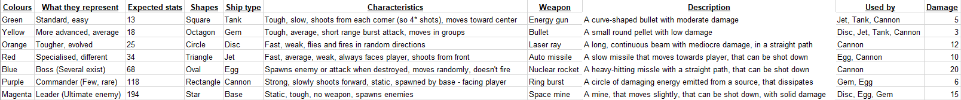Figure 10: The table of ship types, descriptions and statistics, for each type of ship intended to be implemented in the game: (Antony Boys, 2017)

Figure 11: A copy of the tests to be conducted on our project (a full system test):

|  |  |  |
| --- | --- | --- |
| **Test Id** | **Function tested** | **Expected outcome of the function** |
| 1 | Game program loads | The program loads correctly upon launch |
| 2,a | Play button in main menu functions sufficiently | The user is taken to their current level |
| 2,b | Shop button in main menu functions sufficiently | The user is taken to the in-game shop |
| 2,c | High scores button in main menu functions sufficiently | The user is shown the high scores database |
| 2,d | Quit button in main menu functions sufficiently | The application exits and closes |
| 3,a,I | Movement control in game functions sufficiently | The player moves around the screen |
| 3,a,II | Camera moves with player | The camera follows the player, to wherever the player moves to, whenever the player moves |
| 3,b | Shooting control in game functions sufficiently | The particles relevant to the user's weapon is fired |
| 3,c | Pause button in game functions sufficiently | The pause menu displays over a paused game |
| 4,a | Resume button in pause menu functions sufficiently | The user returns to the game |
| 4,b | Main menu button in pause menu functions sufficiently | The user's level is stored, and the user is taken to the main menu |
| 4,c | Quit button in pause menu functions sufficiently | The user's level is stored, and the application exits and closes |
| 5,a,I | Balance displays in shop | The quantity of currency that the user owns is displayed |
| 5,a,II | Score displays in shop | The total score is the user is displayed |
| 5,a,III | Username displays in shop | The user's chosen name is displayed |
| 5,a,IV | Item names appear in shop | The names of the items for sale in the shop are displayed |
| 5,b,I | Correct amount of lives displays in shop | The quantity of lives that the user owns, plus one, is displayed |
| 5,b,II | Correct amount of health points displays in shop | The maximum amount of health points that the user can own after the upgrade is purchased is displayed |
| 5,b,III | Correct speed displays in shop | The user's speed after the upgrade is purchased is displayed |
| 5,b,IV | Correct fire rate displays in shop | The user's fire rate after the upgrade is purchased is displayed |
| 5,b,V | Correct weapon statistics display in shop | The statistics of the next weapon is displayed |
| 5,b,VI | Correct prices display in shop | The prices of all the articles that are sold within the shop are displayed correctly |
| 5,c,I | Buying an extra life functions sufficiently | The amount of lives that the user owns increases by one, and both the price and the amount displayed in the shop updates, and the user's balance decreases |
| 5,c,II | Buying a health upgrade functions sufficiently | The maximum amount of health points that the user can own increases, and both the price and the amount displayed in the shop updates, and the user's balance decreases |
| 5,c,III | Buying a speed upgrade functions sufficiently | The user's maximum speed increases, and both the price and the amount displayed in the shop updates, and the user's balance decreases |
| 5,c,IV | Buying a fire rate upgrade functions sufficiently | The user's fire rate increases, and both the price and the amount displayed in the shop updates, and the user's balance decreases |
| 5,c,V | Buying a new weapon functions sufficiently | The user's weapon changes, and the new weapon and its statistics display in the shop, and the user's balance decreases |
| 5,c,VI | Donating functions sufficiently | The user's balance decreases |
| 6,a,I | Level number displays in game scene | The number of the level that the player is currently on is displayed |
| 6,a,II | Balance displays in game scene | The amount of currency that the user owns is displayed |
| 6,a,III | Score displays in game scene | The total score is the user is displayed |
| 6,a,IV | Amount of health displays in game scene | The quantity of health points that the user currently owns is displayed |
| 6,a,V | Amount of lives displays in game scene | The quantity of lives that the user owns is displayed |
| 6,a,VI | Player weapon icon displays in game scene | The icon of the weapon that is currently equipped is displayed |
| 6,a,VII | Player weapon name displays in game scene | The name of the weapon that is currently equipped is displayed |
| 6,b,I | Bullet functions sufficiently | The bullet moves in a straight path from its spawn position, and deals 3 damage upon collision |
| 6,b,II | Energy particle functions sufficiently | The energy particle moves in a straight path from its spawn position, and deals 5 damage upon collision |
| 6,b,III | Laser ray functions sufficiently | The laser ray moves in a straight path from its spawn position, and deals 12 damage upon collision |
| 6,b,IV | Space mine functions sufficiently | The space mine moves slightly in random directions from its spawn position, and deals 15 damage upon collision |
| 6,b,V | Ring burst functions sufficiently | The ring burst emits and expands from its spawn position, deals 6 damage upon collision, and is destroyed when it takes 1 or more damage |
| 6,b,VI | Auto missile functions sufficiently | The auto missile moves slowly towards the player, deals 10 damage upon collision, and is destroyed when it takes 1 or more damage |
| 6,b,VII | Nuclear rocket functions sufficiently | The nuclear rocket moves slowly in a straight path from its spawn position, deals 20 damage upon collision, and is destroyed when it takes 1 or more damage |
| 6,c | Shop displays in between levels | The user is taken to the shop upon the completion of any level |
| 7,a,I | Colliding with a +5¤ power-up functions sufficiently | The user's balance increases by 5 |
| 7,a,II | Colliding with a +20¤ power-up functions sufficiently | The user's balance increases by 20 |
| 7,a,III | Colliding with a +100¤ power-up functions sufficiently | The user's balance increases by 100 |
| 7,a,IV | Colliding with a +50% h.p. power-up functions sufficiently | The user's health increases by a maximum of 50%, providing that the total amount of health doesn't exceed 100% |
| 7,a,V | Colliding with a +100% h.p. power-up functions sufficiently | The user's health increases by a maximum of 100%, providing that the total amount of health doesn't exceed 100% |
| 7,b,I | Colliding with a double damage power-up functions sufficiently | The damage dealt by the user's weapons temporarily increases by 100% |
| 7,b,II | Colliding with a double points power-up functions sufficiently | The amount of points scored by the user temporarily increases by 100% |
| 7,b,III | Colliding with a 0.3* reload time power-up functions sufficiently | The user's fire rate temporarily increases by 233% |
| 7,b,IV | Colliding with a triple cash power-up functions sufficiently | The amount of currency power-ups obtained by the user temporarily have their currency value increased by 200% |
| 7,b,V | Colliding with a 2.5* speed power-up functions sufficiently | The user's speed temporarily increases |
| 7,b,VI | Colliding with an invincibility power-up functions sufficiently | The user temporarily becomes immune to receiving damage |
| 7,b,VII | Colliding with an enemies freeze power-up functions sufficiently | The enemies that are displayed on the screen are temporarily unable to move or fire |
| 7,b,VIII | Colliding with a nuke power-up functions sufficiently | The non-boss enemies that are displayed on the screen are destroyed |
| 8,a,I | Green base functions sufficiently | The green base spawns green enemies |
| 8,a,II | Green cannon functions sufficiently | The green cannon shoots a cluster of 3 bullets forward every 3.33 seconds, this unit has 12 health and doesn't move |
| 8,a,III | Green disc functions sufficiently | The green disc shoots a bullet in a random direction every 1.67 seconds, this unit has 6 health and moves at a rate of 15 speed in a random direction |
| 8,a,IV | Green egg functions sufficiently | The green egg has a 90% chance of hatching into 4 ring bursts, and a 10% chance of spawing a green enemy |
| 8,a,V | Green gem functions sufficiently | The green unit shoots a ring burst every 2 seconds, this unit has 11 health and moves at a rate of 3 speed forward |
| 8,a,VI | Green jet functions sufficiently | The green jet shoots an energy particle forward every 2.5 seconds whilst facing the player, this unit has 7 health and moves at a rate of 12 speed forward |
| 8,a,VII | Green tank functions sufficiently | The green tank shoots a bullet from each corner every 5 seconds, this unit has 13 health and moves at a rate of 2 speed forward |
| 8,b,I | Yellow base functions sufficiently | The yellow base spawns yellow enemies |
| 8,b,II | Yellow cannon functions sufficiently | The yellow cannon shoots a nuclear rocket forward every 5 seconds, this unit has 14 health and doesn't move |
| 8,b,III | Yellow disc functions sufficiently | The yellow disc shoots a bullet in a random direction every 1 second, this unit has 8 health and moves at a rate of 16 speed in a random direction |
| 8,b,IV | Yellow egg functions sufficiently | The yellow egg has a 65% chance of hatching into 6 ring bursts, and a 35% chance of spawning a yellow enemy |
| 8,b,V | Yellow gem functions sufficiently | The yellow gem shoots a space mine every 4.29 seconds, this unit has 14 health and moves at a rate of 5 speed forward |
| 8,b,VI | Yellow jet functions sufficiently | The yellow jet shoots a cluster of 3 bullets forward every 3.33 seconds whilst facing the player, this unit has 7 health and moves at a rate of 12 speed forward |
| 8,b,VII | Yellow tank functions sufficiently | The yellow tank shoots an energy particle from each corner every 5.71 seconds, this unit has 15 health and moves at a rate of 4 speed forward |
| 8,c,I | Orange base functions sufficiently | The orange base spawns orange enemies |
| 8,c,II | Orange cannon functions sufficiently | The orange cannon shoots a cluster of 4 enery particles forward every 3.64 seconds, this unit has 20 health and doesn't move |
| 8,c,III | Orange disc functions sufficiently | The orange disc shoots a space mine in a random direction every 3.33 seconds, this unit has 10 health and moves at a rate of 20 speed in a random direction |
| 8,c,IV | Orange egg functions sufficiently | The orange egg has a 45% chance of hatching into 3 space mines, and a 55% chance of spawning an orange enemy |
| 8,c,V | Orange gem functions sufficiently | The orange gem shoots a ring burst every 1.11 seconds, this unit has 15 health and moves at a rate of 6 speed forward |
| 8,c,VI | Orange jet functions sufficiently | The orange jet shoots a bullet and an energy particle forward every 1.82 seconds whilst facing the player, this unit has 11 health and moves at a rate of 20 speed forward |
| 8,c,VII | Orange tank functions sufficiently | The orange tank shoots a cluster of 2 bullets from each corner every 4.44 seconds, this unit has 16 health and moves at a rate of 5 speed forward |
| 8,d,I | Red base functions sufficiently | The red base spawns red enemies |
| 8,d,II | Red cannon functions sufficiently | The red cannon shoots 2 laser rays forward every 3.08 seconds, this unit has 24 health and doesn't move |
| 8,d,III | Red disc functions sufficiently | The red disc shoots a bullet and a space mine in a random direction every 2.72 seconds, this unit has 14 health and moves at a rate of 22 speed in a random direction |
| 8,d,IV | Red egg functions sufficiently | The red egg has a 60% chance of hatching into 6 auto missiles, and a 40% chance of spawning a red enemy |
| 8,d,V | Red gem functions sufficiently | The red gem shoots a ring burst and a space mine every 2.72 seconds, this unit has 19 health and moves at a rate of 13 speed forward |
| 8,d,VI | Red jet functions sufficiently | The red jet shoots a cluster of 2 bullets forward every 0.9 seconds whilst facing the player, this unit has 12 health and moves at a rate of 23 speed forward |
| 8,d,VII | Red tank functions sufficiently | The red tank shoots a bulletand an energy particle from each corner every 4 seconds, this unit has 17 health and moves at a rate of 5 speed forward |
| 8,e,I | Blue base functions sufficiently | The blue base spawns blue enemies |
| 8,e,II | Blue cannon functions sufficiently | The blue cannon shoots a spread of 2 nuclear rockets forward every 2.5 seconds, this unit has 44 health and doesn't move |
| 8,e,III | Blue disc functions sufficiently | The blue disc shoots a ring of 8 bullets every 1.67 seconds, this unit has 30 health and moves at a rate of 30 speed in a random direction |
| 8,e,IV | Blue gem functions sufficiently | The blue gem shoots 3 ring bursts every 1.25 seconds, this unit has 40 health and moves at a rate of 20 speed forward |
| 8,e,V | Blue jet functions sufficiently | The blue jet shoots a spread of 2 energy particles forward every 0.67 seconds whilst facing the player, this unit has 22 health and moves at a rate of 32 speed |
| 8,e,VI | Blue tank functions sufficiently | The blue tank shoots a spread of 3 bullets from each corner every 2.4 seconds, this unit has 40 health and moves at a rate of 14 speed forward |
| 8,f,I | Purple base functions sufficiently | The purple base spawns purple enemies |
| 8,f,II | Purple cannon functions sufficiently | The purple cannon shoots a spread of 5 laser rays forward every 2.22 seconds, this unit has 81 health and doesn't move |
| 8,f,III | Purple disc functions sufficiently | The purple disc shoots a cluster of 3 space mines every 1.67 seconds, this unit has 51 health and moves at a rate of 30 speed in a random direction |
| 8,f,IV | Purple gem functions sufficiently | The purple gem shoots a ring of 3 space mines every 1.11 seconds, this unit has 59 health and moves at a rate of 22 speed forward |
| 8,f,V | Purple jet functions sufficiently | The purple jet shoots 2 spreads of 3 bullets forward every 0.67 seconds whilst facing the player, this unit has 49 health and moves at a rate of 32 speed forward |
| 8,f,VI | Purple tank functions sufficiently | The purple tank shoots 3 bullets and an energy particle from each corner every 2 seconds, this unit has 55 health and moves at a rate of 16 speed forward |
| 8,g,I | Magenta base functions sufficiently | The magenta base spawns magenta enemies |
| 8,g,II | Magenta cannon functions sufficiently | The magenta cannon shoots 2 auto missiles and 2 nuclear rockets forward every 1.25 seconds, this unit has 102 health and doesn't move |
| 8,g,III | Magenta disc functions sufficiently | The magenta disc shoots 4 bullets in a random direction and 3 space mines every 1.25 seconds, this unit has 86 health and moves at a rate of 40 speed in a random direction |
| 8,g,IV | Magenta gem functions sufficiently | The magenta gem shoots a ring burst and a ring of 4 space mines every 1.43 seconds, this unit has 95 health and moves at a rate of 25 speed forward |
| 8,g,V | Magenta jet functions sufficiently | The magenta jet shoots a spread of 3 energy particles forward every 0.33 seconds whilst facing the player, this unit has 85 health and moves at a rate of 32 speed forward |
| 8,g,VI | Magenta tank functions sufficiently | The magenta tank shoots 4 bullets and an energy particle from each corner every 1.43 seconds, this unit has 84 health and moves at a rate of 22 speed forward |
| 9,a,I | Banner advertisements display in main menu | The main menu contains a functioning banner advertisement somewhere on the screen |
| 9,a,II | Banner advertisements display in pause menu | The pause menu contains a functioning banner advertisement somewhere on the screen |
| 9,a,III | Banner advertisements display in shop menu | The shop menu contains a functioning banner advertisement somewhere on the screen |
| 9,b | Interstital advertisements display in between screens | The interstital page between levels, the shop, and pages of the menu, all contain a functioning advertisement |
| 9,c | High scores are sent to database when game ends | The user's total score is sent to the high scores database to be stored |
| 9,d | Current high scores display when button is tapped | The high scored database that is displayed is consistently updating when new high scores are enterd |
| 9,e,I | Database stores player's statistics and progress | The user's current statistics and progress, consisting of scores, currency balance, level, upgrade purchases and life quantity, are stored in the database |
| 9,e,II | Database loads player's statistics and progress | The user's stored statistics and progress, consisting of scores, currency balance, level, upgrade purchases and life quantity, are accessed and loaded into the game |

(Antony Boys, 2017)

Figure 12:

# References

1. Anthony Boys, 2017. *Copy of Meeting Minutes* [Viewed on the 10/01/2018]. Available from: <https://drive.google.com/open?id=1zxLlAtjeqHG9ca_-QfohmyLYrLHpk49oHcUAeVVD6rI>